Phase 2: Flow Designer and Process Automation

1. Phase Overview
The primary objective of Phase 2 is to automate the approval routing and task fulfillment lifecycle for the Car Rental Request catalog item using ServiceNow Flow Designer. This phase eliminates manual intervention by automatically triggering an approval process to the manager and generating a catalog task (SCTASK) for the fleet fulfillment team upon approval.

2. Configuration Details

A. Flow Metadata
- Flow Name: Car Rental Request Flow
- Trigger: Application $→$ Service Catalog
- Target Record: Requested Item (sc_req_item)
- Status: Published

B. Flow Action & Logic Specifications

Step # | Action Name | Configuration / Details | Condition / Logic
1 | Trigger | Service Catalog Trigger | Fires upon submission of "Car Rental Request"
2 | Ask for Approval | Target Record: Trigger -> Requested Item  Approver: Requested For -> Manager (or designated approver, e.g., Abraham Lincoln) | Approval rule: Approve when any one approves
3 | If / Else Condition | Check Approval State | If: Approval State == Approved  Else If: Approval State == Rejected
4a | Create Catalog Task | Task Table: Catalog Task [sc_task]  Short Description: "Assign vehicle and hand over keys to employee"  Assignment Group: Fleet Fulfillment Team | Executes when Step 3 condition is Approved
4b | Update Record | Target: Trigger -> Requested Item  State: Closed Rejected / Cancelled | Executes when Step 3 condition is Rejected
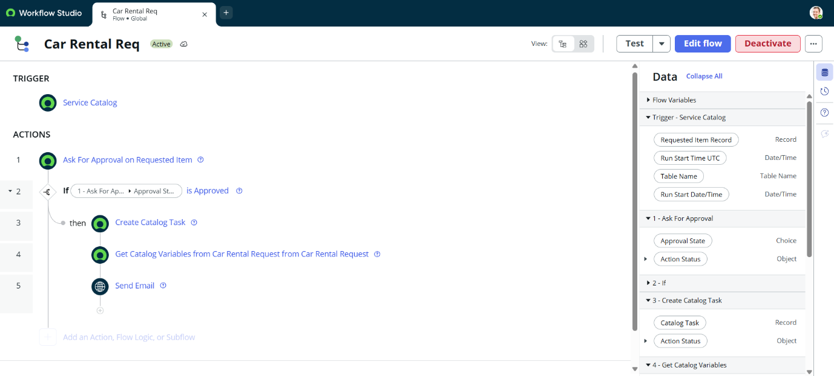
Figure 2.1: Flow Designer Workflow Architecture & Logic Setup
3. Execution & Verification Steps
- Flow Creation & Setup:
  - Opened Process Automation > Flow Designer.
  - Created a new Flow named Car Rental Request Flow with Service Catalog as the trigger.
- Approval Action Configuration:
  - Added the Ask for Approval action mapped dynamically to the RITM record and assigned the approver.
- Task Generation Logic:
  - Added an If condition branch checking for approval success.
  - Configured Create Catalog Task action to auto-generate SCTASK for vehicle assignment.
- Testing & Activation:
  - Tested the flow execution using sample RITM records.
  - Published the flow and linked it to the Car Rental Request Catalog Item under the Process Engine configuration.

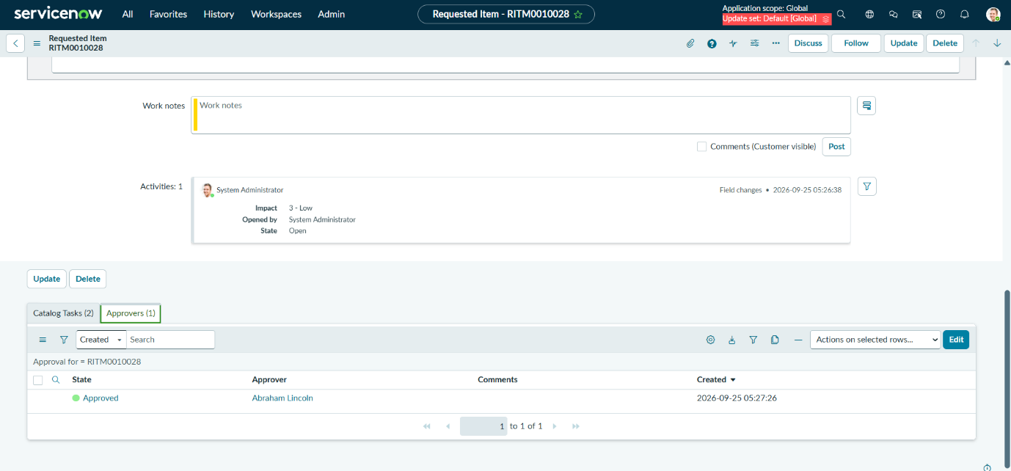
Figure 2.2: RITM Approval Lifecycle Verification & Tracking

